**Task 3**

Created date of the table AdventureWorks2017.Person.Person is 21/10/2017 14:30

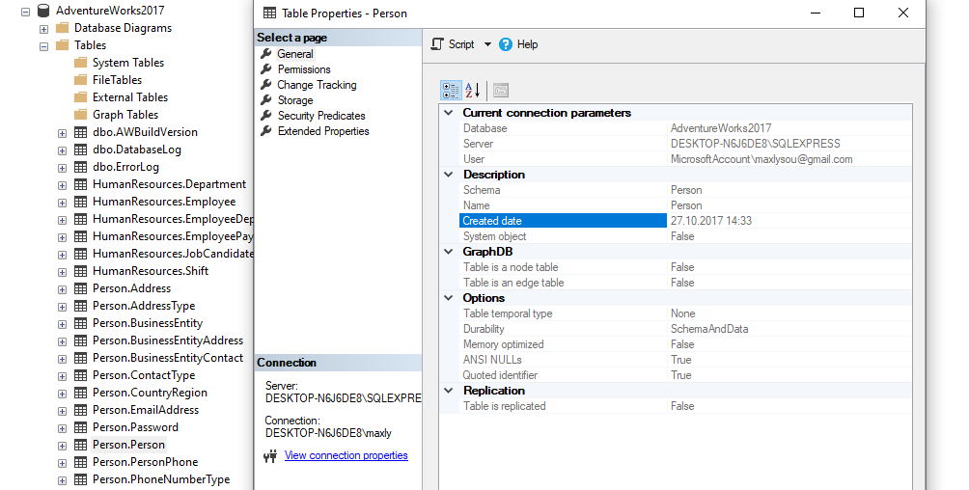

**Task 4**

Data space of the table AdventureWorksDW2017.dbo.DimPromotion is 0.008 Mb (8388.61 b)

